AI ASSISTED CODING
ASSIGNMENT-8
M.Shivamani
2303A52344
Batch:38
Lab 8: Test-Driven Development with AI – Generating and Working with Test Cases
Lab Objectives:
• To introduce students to test-driven development (TDD) using AI code generation tools.
• To enable the generation of test cases before writing code implementations.
• To reinforce the importance of testing, validation, and error handling.
• To encourage writing clean and reliable code based on AI-generated test expectations.
Task 1 – Test-Driven Development for Even/Odd Number Validator
• Use AI tools to first generate test cases for a function is_even(n) and then implement the function so that it satisfies all generated tests.
Requirements:
• Input must be an integer
• Handle zero, negative numbers, and large integers
Example Test Scenarios:
is_even(2) → True
is_even(7) → False
is_even(0) → True
is_even(-4) → True
is_even(9) → False
Expected Output -1
• A correctly implemented is_even() function that passes all AI-generated test cases
Prompt:
Generate comprehensive test cases for a Python function is_even(n) using Test-Driven Development. The function should accept only integers and correctly handle zero, negative values, and very large integers. Then implement is_even(n) so that it passes all the generated test cases.
Explanation:
This prompt first instructs the AI to follow a TDD approach by creating test cases before writing any code. The test cases ensure correctness for normal, edge, and boundary inputs like zero, negatives, and large numbers. After defining the expected behavior through tests, the function is implemented to satisfy them. This approach improves reliability and reduces logical errors. It also demonstrates good software engineering practice by validating requirements through tests first.
Code & Output:
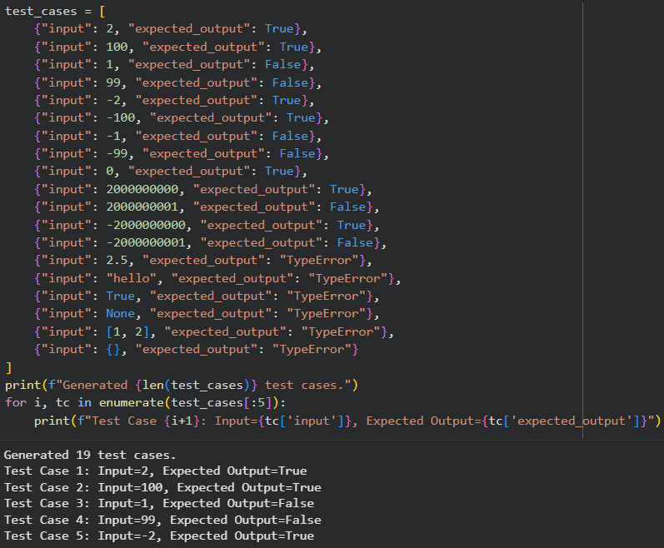
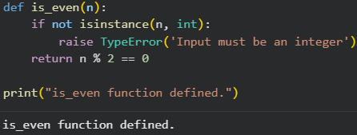
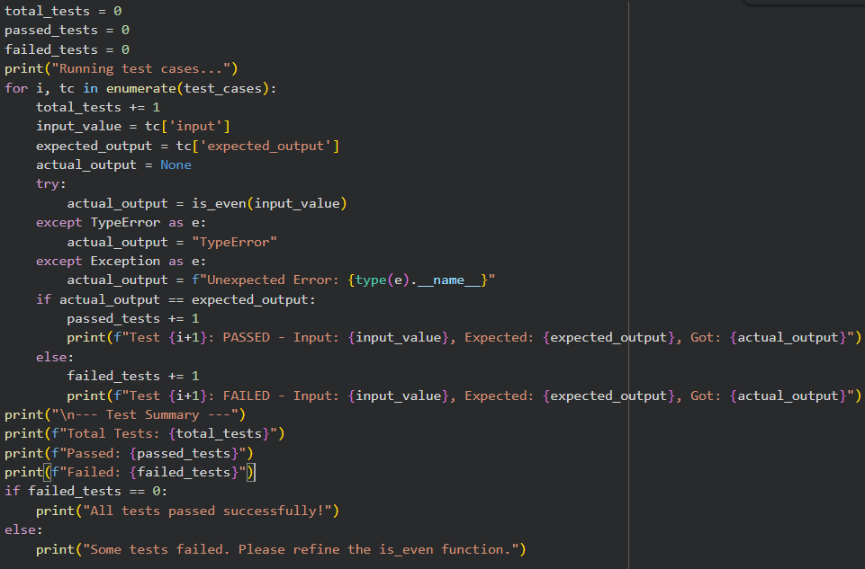
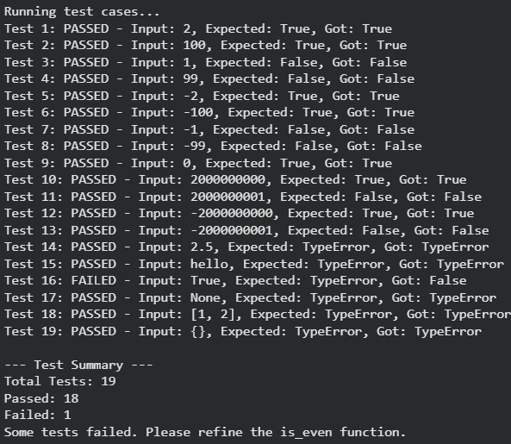
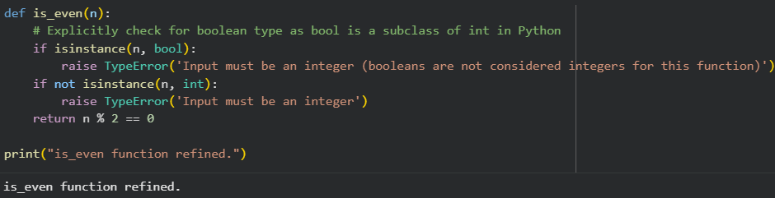
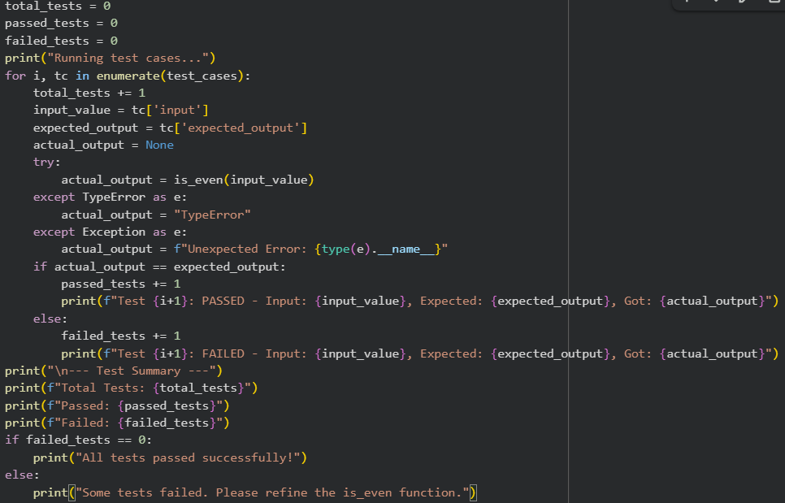
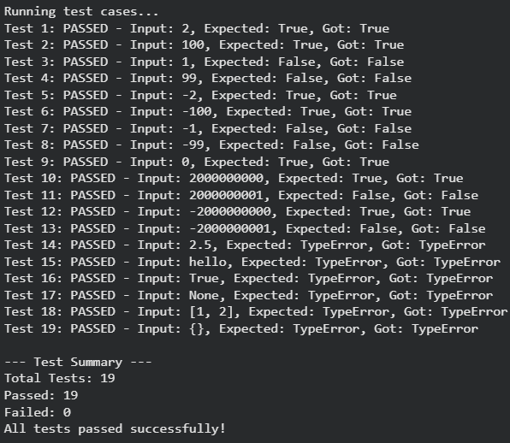
Task 2 – Test-Driven Development for String Case Converter
• Ask AI to generate test cases for two functions:
• to_uppercase(text)
• to_lowercase(text)
Requirements:
• Handle empty strings
• Handle mixed-case input
• Handle invalid inputs such as numbers or None
Example Test Scenarios:
to_uppercase("ai coding") → "AI CODING"
to_lowercase("TEST") → "test"
to_uppercase("") → ""
to_lowercase(None) → Error or safe handling
Expected Output -2
• Two string conversion functions that pass all AI-generated test cases with safe input handling.
Prompt:
Using Test-Driven Development, generate comprehensive test cases for two Python functions: to_uppercase(text) and to_lowercase(text). The functions must handle empty strings, mixed-case input, and safely handle invalid inputs such as numbers or None. Then implement both functions so that they pass all generated test cases.
Explanation:
This prompt instructs the AI to follow a TDD workflow by creating test cases before writing the functions. The test cases cover normal inputs, edge cases like empty strings, and invalid inputs to ensure robustness. Safe handling of errors is emphasized to avoid runtime failures. After defining expected behavior through tests, the functions are implemented accordingly. This approach ensures correctness, reliability, and defensive programming practices.
Code & Output:
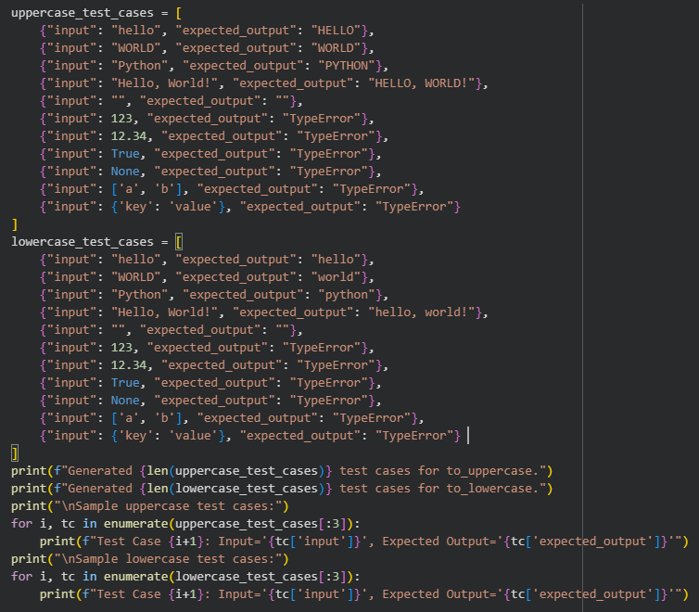
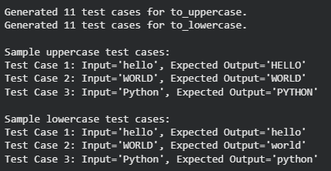
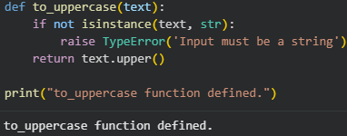
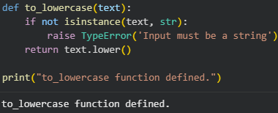
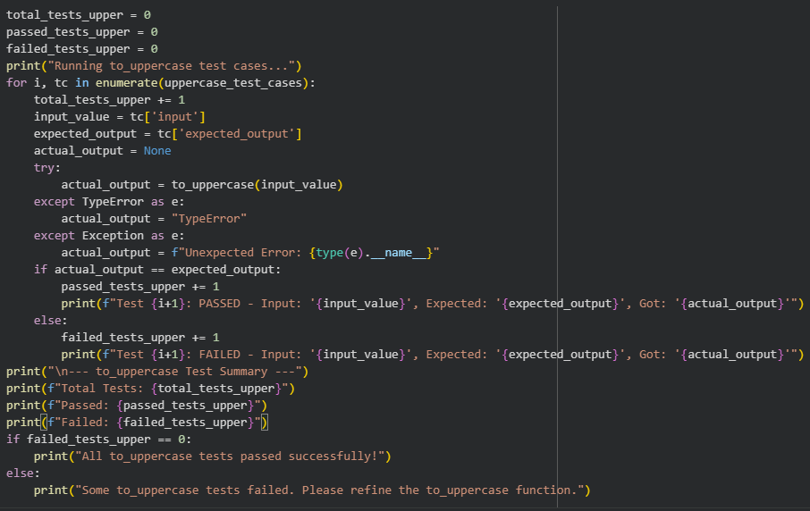
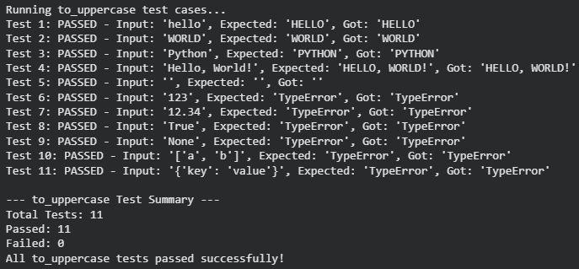
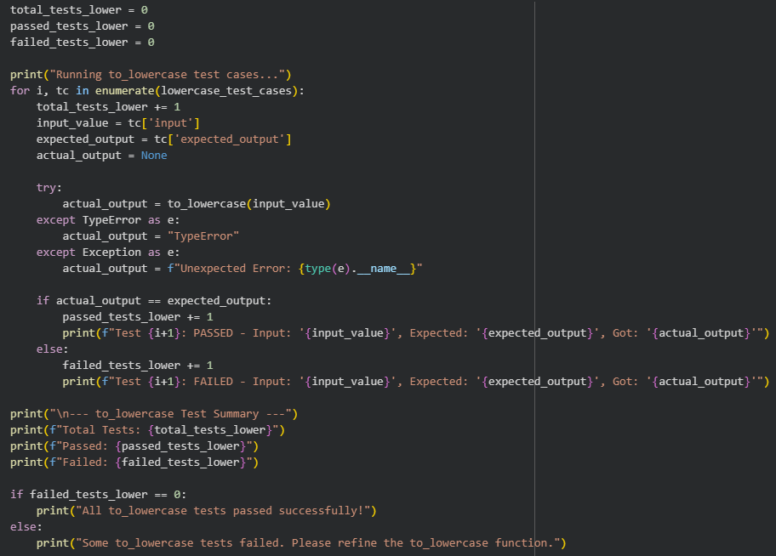
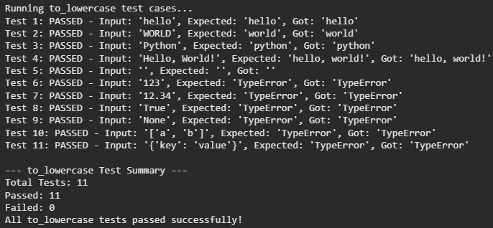
Task 3 – Test-Driven Development for List Sum Calculator
• Use AI to generate test cases for a function sum_list(numbers) that calculates the sum of list elements.
Requirements:
• Handle empty lists
• Handle negative numbers
• Ignore or safely handle non-numeric values
Example Test Scenarios:
sum_list([1, 2, 3]) → 6
sum_list([]) → 0
sum_list([-1, 5, -4]) → 0
sum_list([2, "a", 3]) → 5
Expected Output 3
• A robust list-sum function validated using AI-generated test cases.
Prompt:
Apply Test-Driven Development to generate test cases for a Python function sum_list(numbers) that computes the sum of list elements. The function should handle empty lists, negative numbers, and safely ignore or handle non-numeric values. Then implement the function so that it passes all generated test cases.
Explanation:
This prompt guides the AI to first define expected behavior through test cases before writing the function. The tests cover normal usage, edge cases like empty lists, and robustness against invalid elements. By ignoring or safely handling non-numeric values, the function avoids runtime errors.Implementing the function after tests ensures it strictly meets the defined requirements. This demonstrates reliable and defensive coding using the TDD approach.
Code & Output:
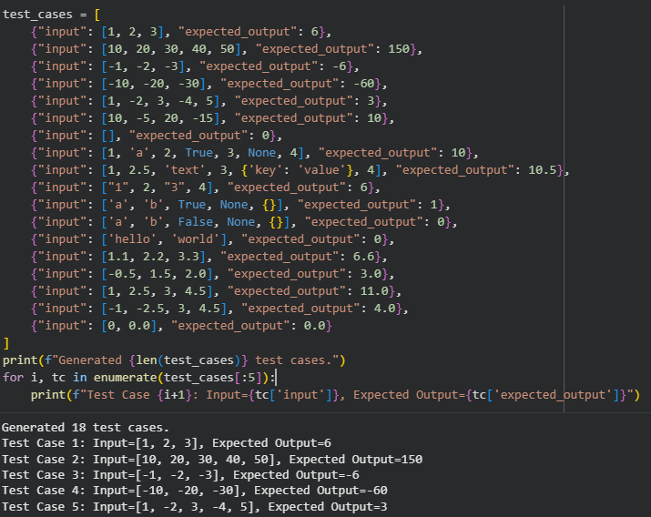
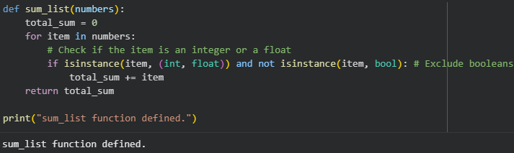
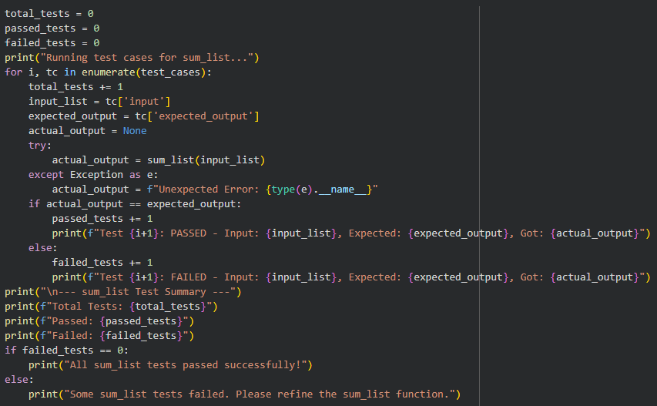
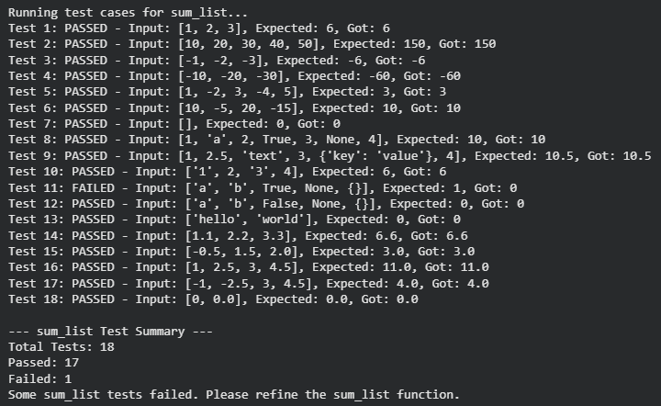
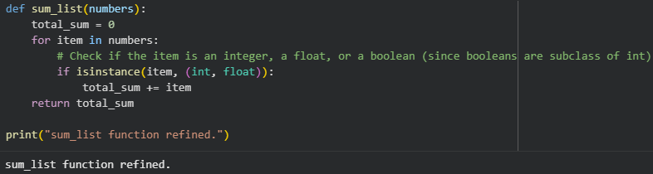
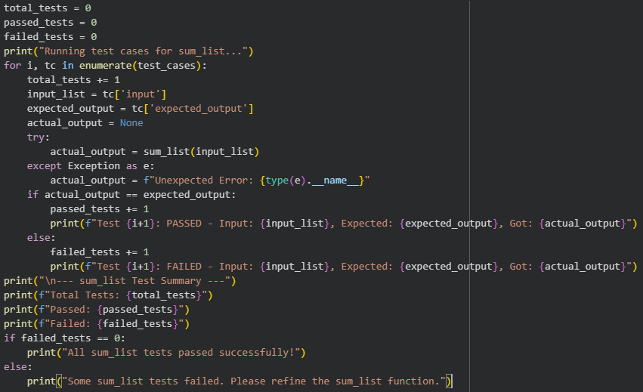
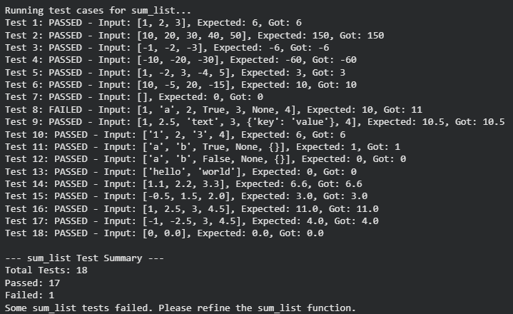
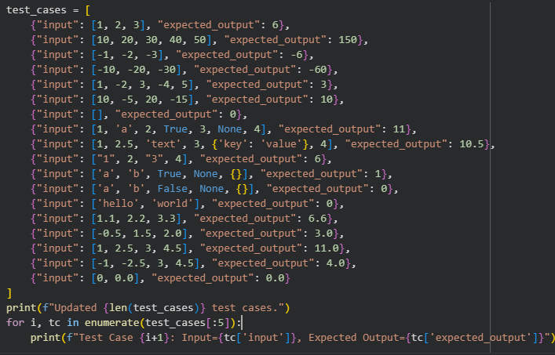
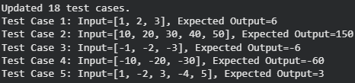
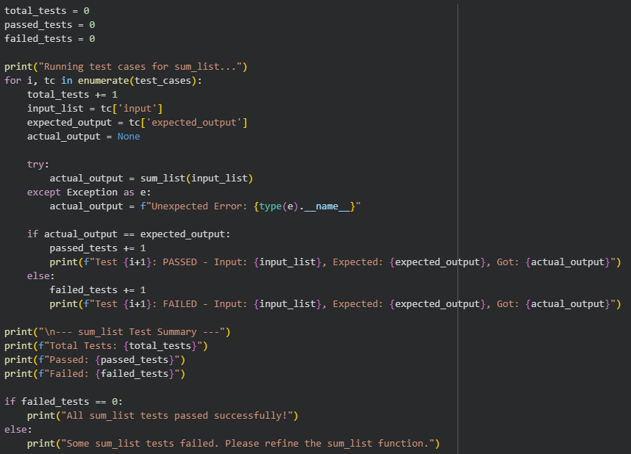
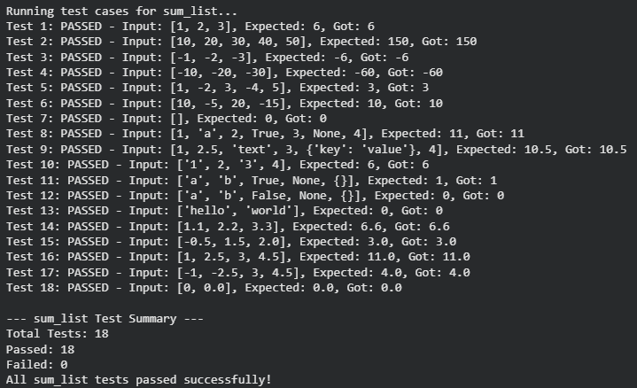
Task 4 – Test Cases for Student Result Class
• Generate test cases for a StudentResult class with the following methods:
• add_marks(mark)
• calculate_average()
• get_result()
Requirements:
• Marks must be between 0 and 100
• Average ≥ 40 → Pass, otherwise Fail
Example Test Scenarios:
Marks: [60, 70, 80] → Average: 70 → Result: Pass
Marks: [30, 35, 40] → Average: 35 → Result: Fail
Marks: [-10] → Error
Expected Output -4
• A fully functional StudentResult class that passes all AI- generated test
Prompt:
Using Test-Driven Development, generate test cases for a Python Student Result class with methods add_marks(mark), calculate_average(), and get_result(). Marks must be validated between 0 and 100, and the result should be ‘Pass’ if the average is ≥ 40, otherwise ‘Fail’. Then implement the class so that it passes all the generated test cases.
Explanation:
This prompt instructs the AI to follow a TDD approach by defining test cases before implementing the class. The test cases cover valid marks, boundary conditions, and invalid inputs such as negative marks. Validation ensures only acceptable marks are processed, preventing incorrect averages. The pass/fail logic is verified through average calculation tests. Implementing the class after testing guarantees correctness, robustness, and adherence to requirements.
Code & Output:
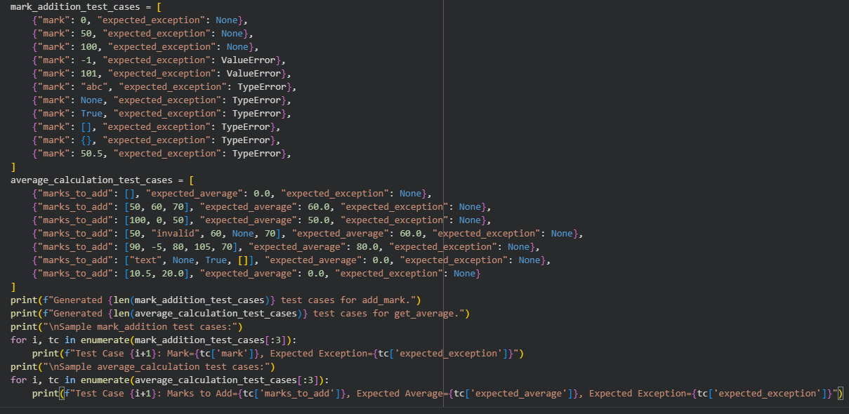
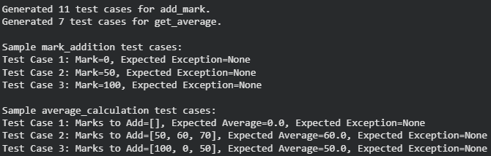
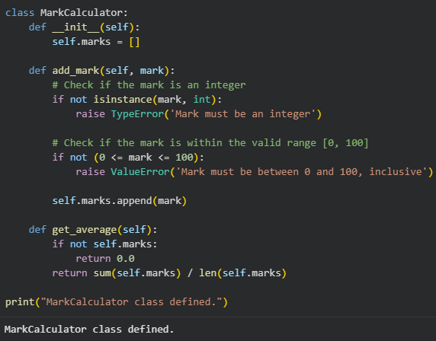
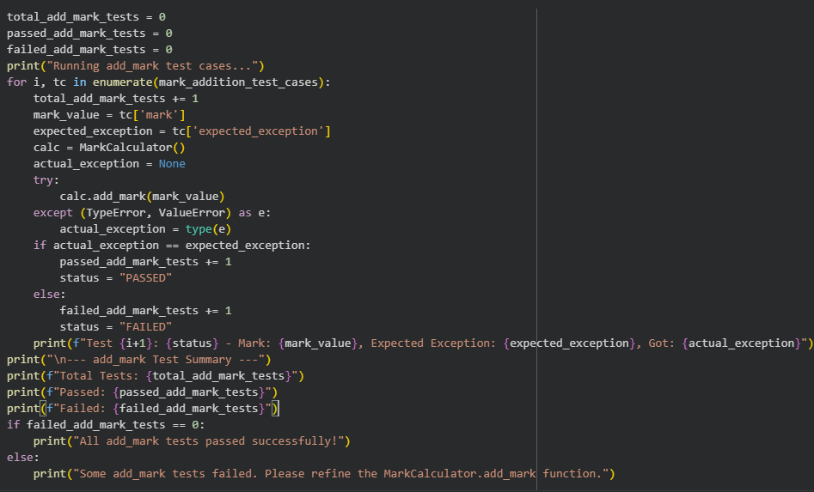
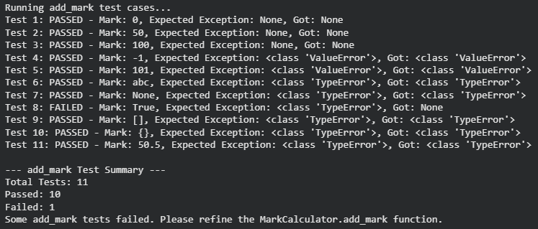
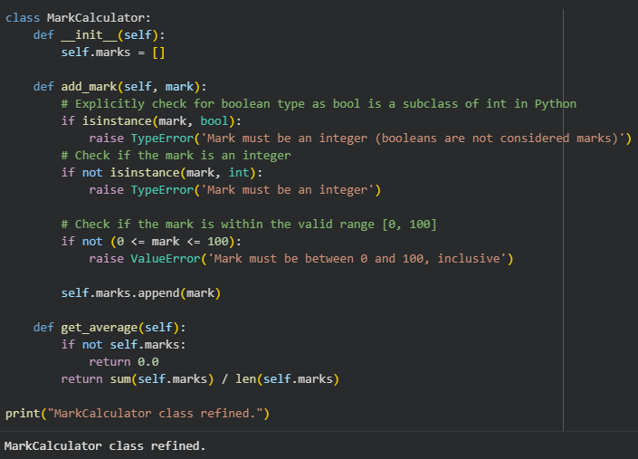
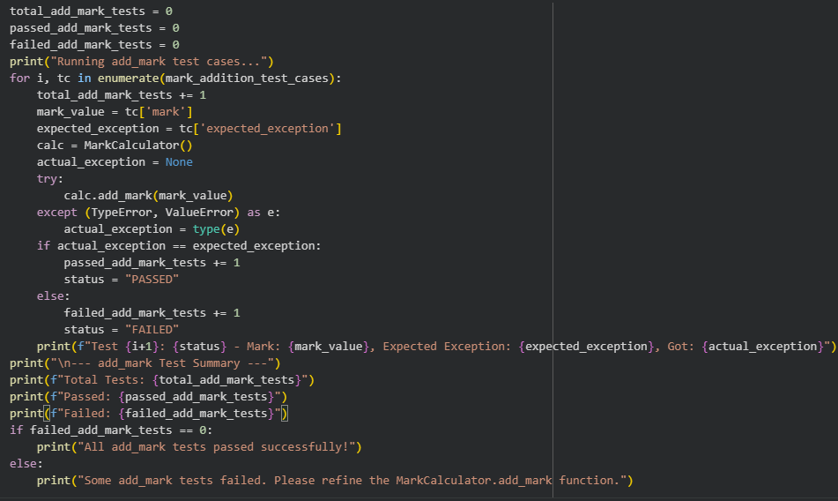
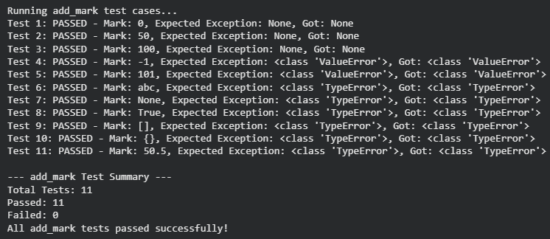
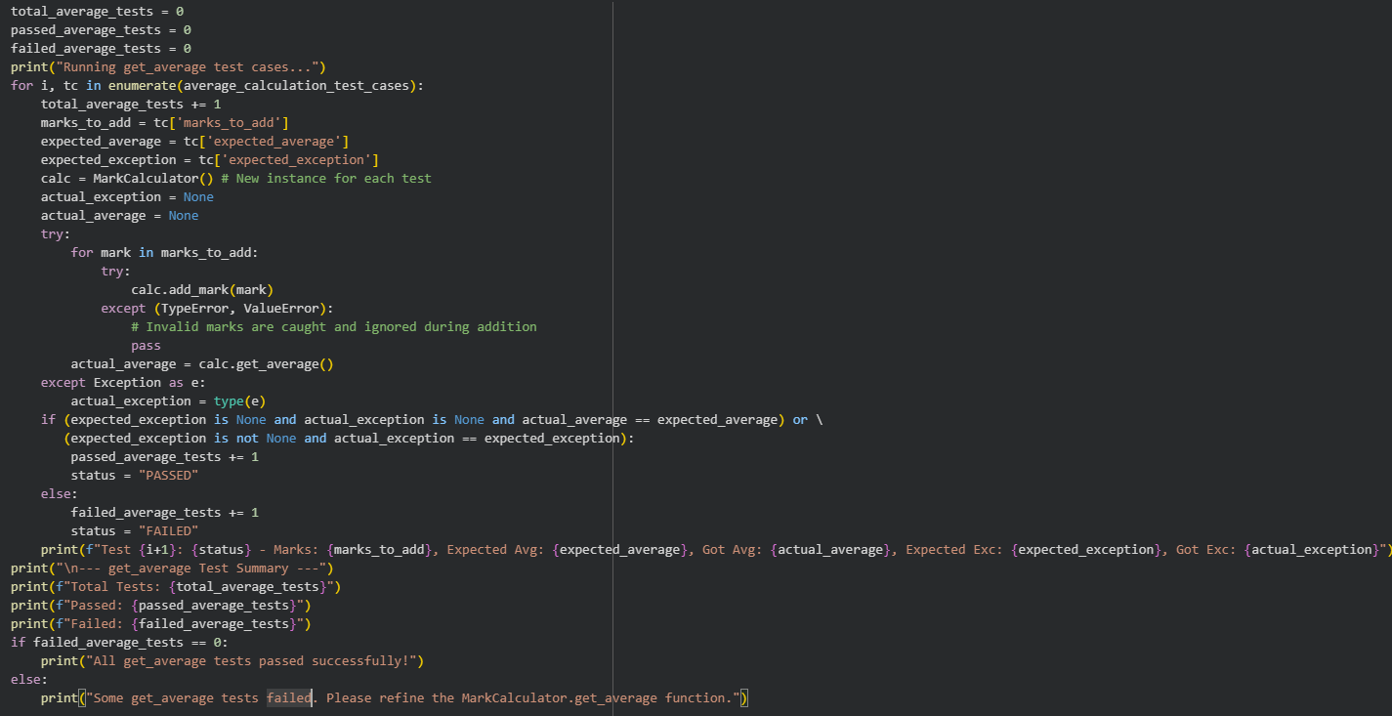
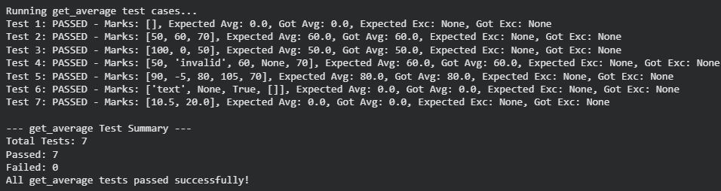
Task 5 – Test-Driven Development for Username Validator
Requirements:
• Minimum length: 5 characters
• No spaces allowed
• Only alphanumeric characters
Example Test Scenarios:
is_valid_username("user01") → True
is_valid_username("ai") → False
is_valid_username("user name") → False
is_valid_username("user@123") → False
Expected Output 5
A username validation function that passes all AI-generated test cases.
Prompt:
Use Test-Driven Development to generate test cases for a Python function is_valid_username(username).The username must be at least 5 characters long, contain only alphanumeric characters, and must not include spaces.
Then implement the function so that it passes all generated test cases.
Explanation:
This prompt directs the AI to first define test cases that capture all username validation rules. The tests include valid usernames and invalid cases such as short length, spaces, and special characters. By writing tests first, the expected behavior is clearly specified. The function implementation is then guided entirely by these tests. This ensures the final validator is accurate, secure, and meets all requirements.
Code & Output:
